NM-1445
UI: Corporate Pricing Search Page
Description

User Story: Corporate Pricing Search
- Search Criteria Section
This section handles the user's ability to narrow down the visible price books.
- Logic: All filtering in this section must be performed client-side. No API calls should be triggered when typing or selecting filters.
- Fields: Pricebook,Price Strategy, Location, Currency, is Internal, Is Labor, Active Only (all boolien)
- Reset Button: * Must clear all active filter inputs.
  - Must reset the component state to show the original, full list of price books.
  - Must return all dropdowns/text fields to their default/empty state.
Navigation Links
- New Pricing:
  - Type: Simple navigation link (styled as a button).
  - Behavior: Redirects to the New Pricing page (I will provide the url once the page is created).
  - Parameters: Must pass either equipment pricing or labor pricing as a route parameter based on the user's selection.
- Price Over-ride:
  - Type: Redirect link (styled as a button).
  - Behavior: Redirects to a separate page (I will provide the url once the page is created).
  - URL: [To Be Determined] (Placeholder for now).
- Data Table Section
This section displays the core system data.
- Initialization: Upon component load the system must call the [/api/Pricebook/All/List] to populate the table.
- Columns/Fields to Display:
  - Price Book (Name/ID)
  - Price Book Strategy
  - Price Year
  - is GSO (Boolean/Toggle)
  - is Internal (Boolean/Toggle)
  - is Labor (Boolean/Toggle)
  - is Active (Status Indicator)
  - Productions Currency

Technical Logic & API Placeholders
Feature | API Placeholder | Purpose
Fetch Pricebooks | [/api/Pricebook/All/List] | Loads available pricbooks IsActive=true for main datatable.
Fetch Locations | [/location/search] | Loads global list of locations for locations dropdown
Load Currencies | [core/currencies] | Loads list of all currencies for currency dropdown
Standalone Web component
Use corporate-pricing-container component for this ticket as this coponent is exposed to the host as stanalone web component.
src/client/apps/navigator/components/locations/slug/settings/corporate-pricing/corporate-pricing-container.tsx

Endpoints:
 | Endpoint | Method
Get Pricing | Call [/api/Pricebook/All/List] | getAllPricebooksList()
Search Pricing (Work in Progress) | Call [API_Endpoint] | Missing

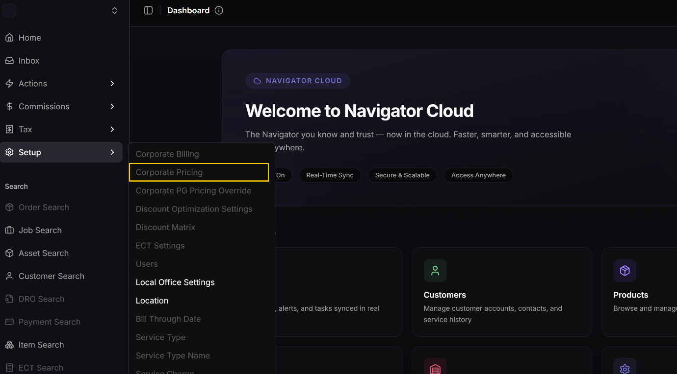

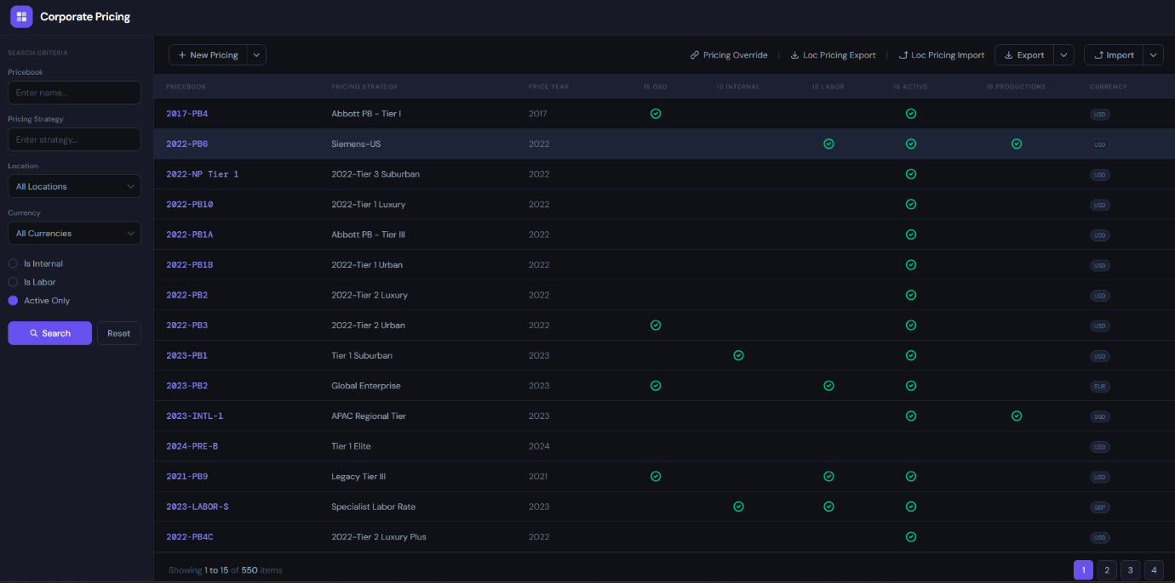

NM-1440
UI: New Pricebook
Description

As a Pricing Administrator (Revenue Management Role is needed),
I want a dedicated interface to initialize a new price book with specific metadata and strategies,
So that I can establish a pricing foundation that can either be populated manually or via a bulk data import.

1. Basic Header Information
This section captures the primary metadata required to identify the price book.
- Price Book Name:
  - Requirement: Mandatory/Required field.
  - Validation: The system must prevent saving if this field is null or empty.
- Price Book Type: A dropdown to select between Equipment or Labor.
- Price Year: A field to specify the fiscal or calendar year the pricing applies to (e.g., 2027) Required.
- Currency: A selection for the intended currency (defaults to USD).

2. Pricing Strategies Section
This section allows the user to define the logic and types of pricing assigned to the book.
- Multi-Strategy Logic: Users can add an multiple number of strategies to a single price book.
- Add Strategy Action:
  - Fields Required: Strategy Name and Strategy Type (e.g., Production).
  - Behavior: Upon clicking "Add," the strategy is appended to the list and associated with the current price book session.
- View: Displays a summary list of all strategies currently assigned to the draft.

4. Final Actions
- Save: * Validation: Checks that the Price Book Name is present.
  - Action: Commits the header info, all added strategies, and any manually selected product groups to the database.

Technical Note for Developers:
- Ensure the "Save" API call handles the empty product group array gracefully to support the "Empty Shell" import workflow without triggering validation errors.
- Use CorporatePricingUpsert component
Technical Logic & API Placeholders
Feature | API Placeholder | Purpose
Fetch Product Groups Product Groups | [GET_PRICEGROUPS_API] | Retrieves the list of all product groups
Commit New Pricebook Data | [/api/pricbook/save] | Handles the "Save" action for new pricebook

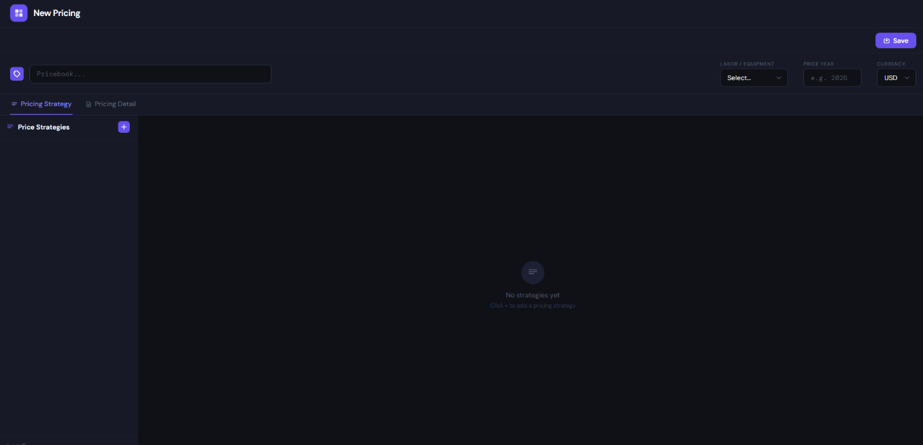

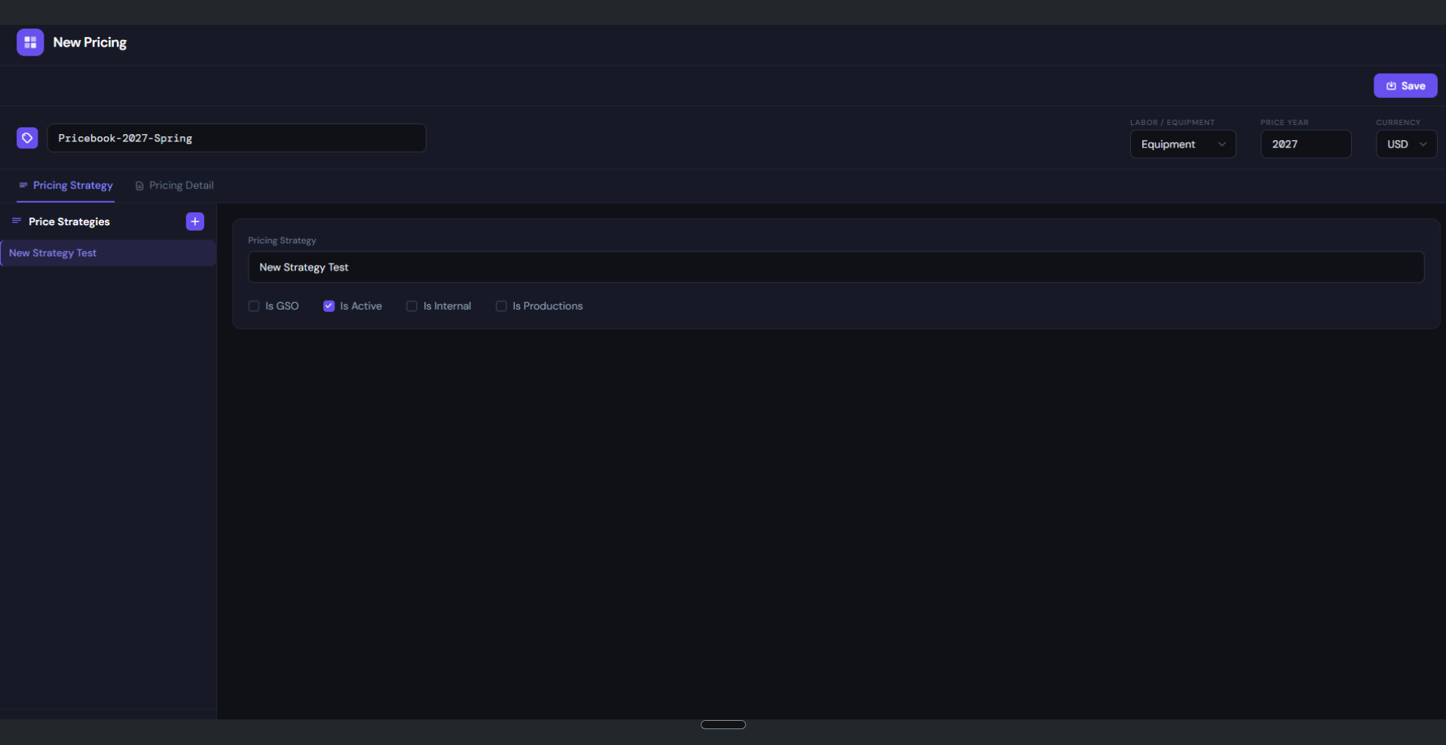Empty Shell when Importing Data using bulk import

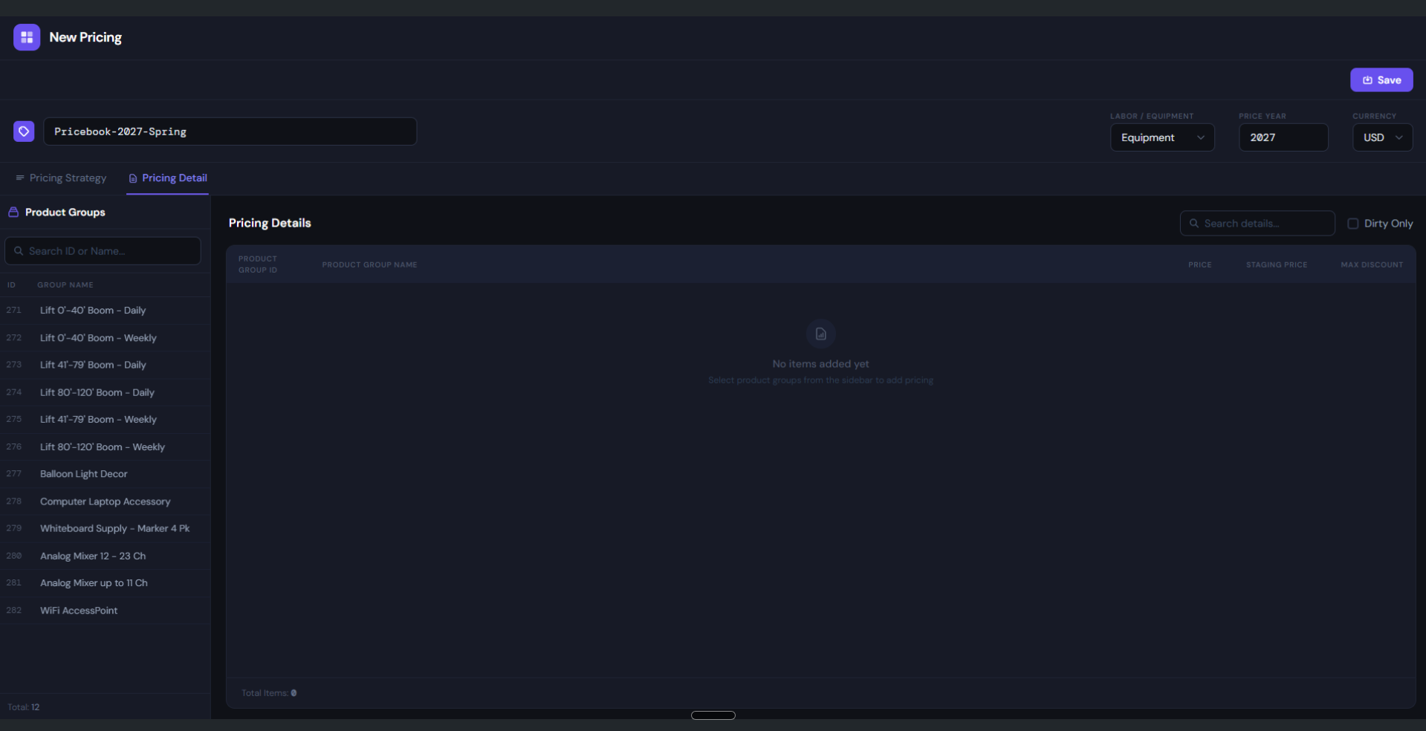

Add product groups manually

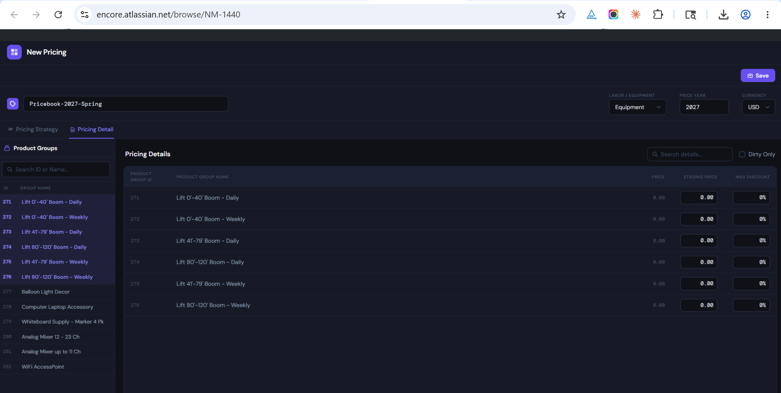

NM-1441
UI: Pricebook Management - Pricing Strategy Tab
Description

As a Pricing Administrator,
I want to navigate from the search results to a detailed management view for a specific price book, so that I can modify existing pricing strategies, add new ones, and view associated location data.

1. Navigation & Context Header
This section establishes the context of the price book being managed.
- Entry Point: Triggered by clicking a specific Price Book Link from the main Search/Management page (NM-1445).
- Header Metadata: * Displays core info: Price Book Name, Type (Labor/Equipment), Year, Currency, and Active Status.
  - Behavior: These fields serve as the primary reference for the strategies being edited below.

2. Tabbed Interface
To organize complex data, the component is divided into three primary views:
- Pricing Strategy (Active): The primary focus for managing strategy logic and locations.
- Pricing Detail: (Placeholder) NM-1443
- History: (Placeholder) NM-1444.

3. Pricing Strategy Management
This is the core functional area for the current component.
- Strategy Selection:
  - Behavior: Clicking an item in the strategy list loads its specific details (e.g., Production, Internal, GSO, Active status).
  - Location Mapping: Displays a list of all locations currently assigned to the selected strategy.
- Editing Existing Strategies:
  - Users can modify the details of strategies already attached to the price book.
- Adding New Strategies:
  - Action: "Add New" button allows users to append a fresh strategy to the current list.
  - Removal Logic: * New Strategies: Display a Remove button allowing the user to delete the entry before it is committed to the database.
    - Existing Strategies: The Remove button is hidden/disabled for strategies that were already part of the price book record.

4. Global Actions
- Save: * Action: Commits all changes made to existing strategies and finalizes the addition of any new strategies to the database.
  - Feedback: Provides confirmation that the Price Book configuration has been updated.

Technical Note for Developers:
- The UI must distinguish between "Dirty" state (newly added strategies or modified existing ones) and "Clean" state. The Remove button logic must be strictly bound to the isNew metadata property of the strategy object to prevent accidental deletion of legacy data.
- Use CorporatePricingUpsert component
Technical Logic & API Placeholders
Feature | API Placeholder | Purpose
Fetch Pricebook Details | [GET_PRICE_BOOK_DETAIL_API] | Retrieves the complete details of a Price Book, including its core metadata such as identifier, name, year, currency, and active status, along with all associated configurations. This includes the list of strategies (e.g., Production, Internal, GSO) tied to the price book, the locations with name and id, and the pricing details for each product group with base price, staging price, and maximum allowed discount.  Please refer comment for the example object response.
Commit Pricebook Data | [UPDATE_PRICEBOOK_DATA_API] | Handles the "Save" action for updated price book details and the creation of newly added strategy records.
Fetch Product Group List | [GET_PRODUCT_GROUP_API] | Gets the list of all product groups

Layout Mockup only, the color schema will be inherited from current setup in Navigator

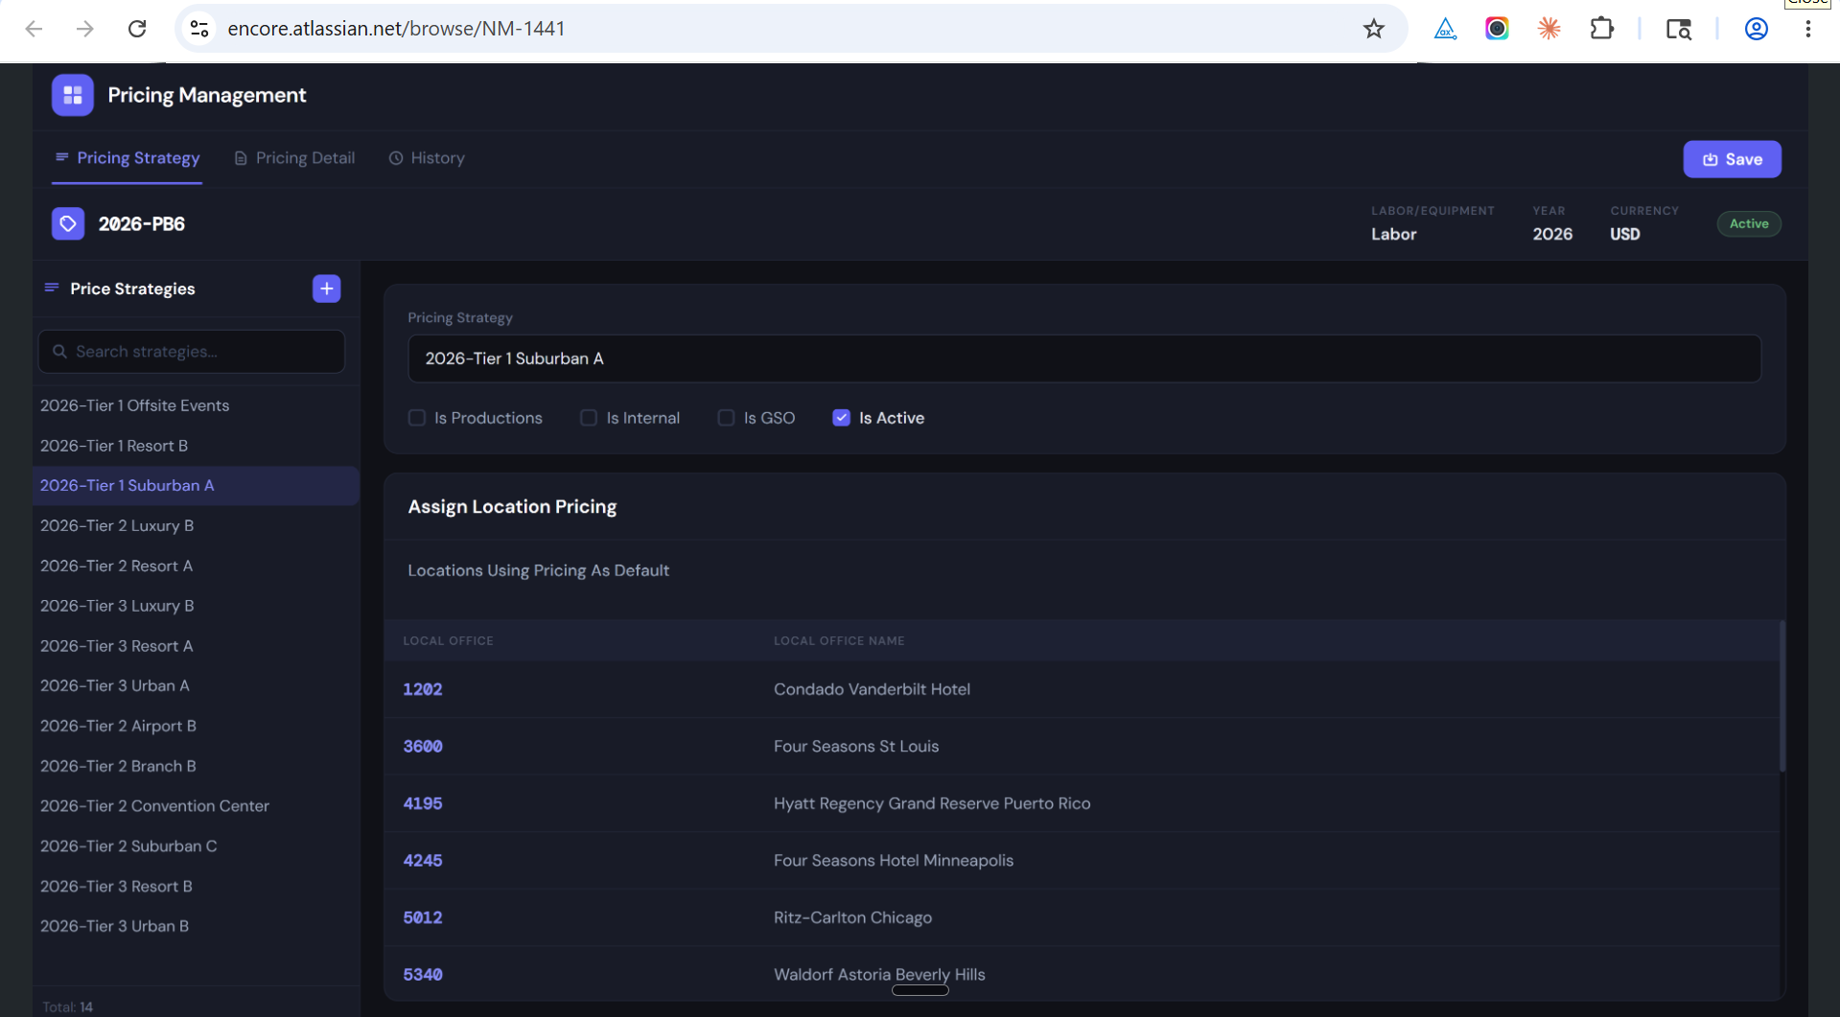
New Strategy Button Clicked
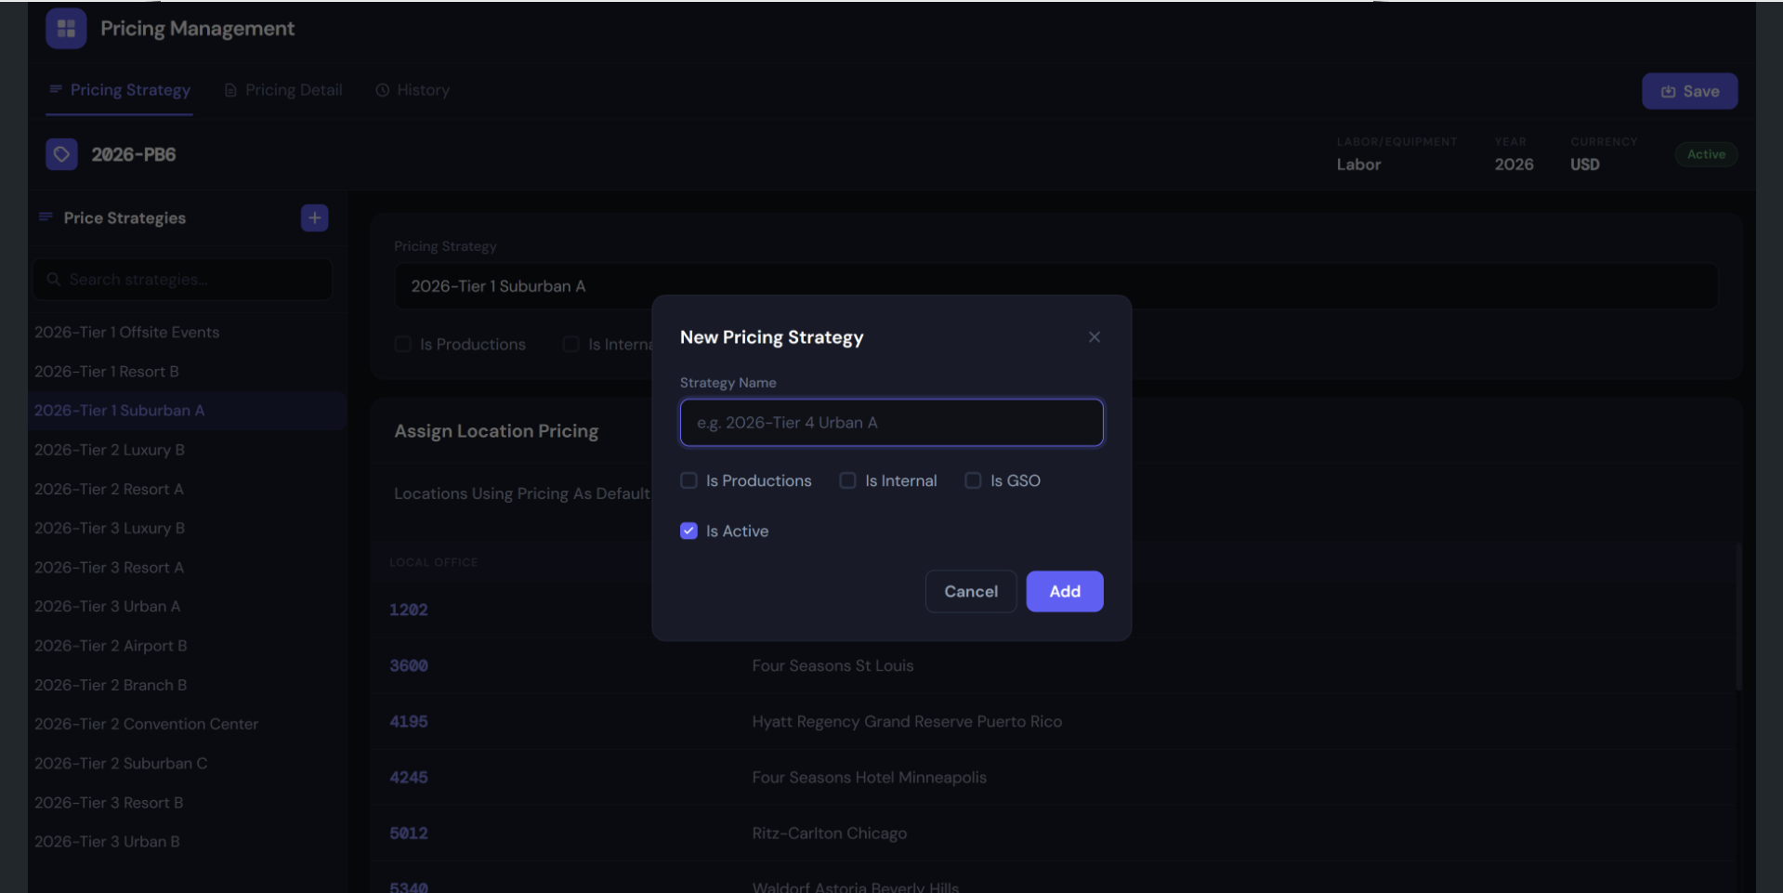

NM-1443
UI: Pricing Details Tab in New Pricebook and Pricebook Management
Description

As a Pricing Administrator,
I want to add product groups in the new pricebook and manage the specific product groups within existing price book,
So that I can apply granular price overrides and discounts at the product level.

1. Product Group Selection (Source)
This section allows the user to browse and select the groups that will define the price book’s content.
- Available Product Groups List: * Behavior: Displays a comprehensive list of all available product groups retrieved via [GET_PRODUCT_GROUPS_API].
- New pricing Page
  - Selection Interactions:
    - Double-Click: Automatically appends the selected group to the Pricing Details list.
    - Drag-and-Drop: Allows users to visually move a product group from the "Available" list into the "Active" Pricing Detail grid.
- Price Managment Page
  - Selection Interactions:
    - Single-Click: Display the selected group to the Pricing Details list.
    - Double Click and Drag-and-Drop: Not allowed as new product groups cant be added.

2. Pricebook Management - Pricing Details Grid
This is the main workspace where the actual pricing logic is applied to the selected groups.
- Data Loading: On tab activation, the system loads existing details using [GET_PRICING_DETAILS_API].
- Group & Item Hierarchy:
  - The grid displays Product Groups, which can be expanded to show Individual Items/Products.
- Editable Fields:
  - Override Price: Allows the user to enter a new price that supersedes the base value.
  - Override Discount: Allows the user to apply a specific percentage or flat discount to the item.
- Read-Only Reference:
  - Base Price: Displays the original global price for reference to ensure the administrator can see the variance.
3. New Pricebook - Pricing Details Grid
This section handles the association of products to the price book.
- User can double click or drop and drop Individual product group to this section.
- User can add or remove the Product groups in this section.

3. Data Persistence & Actions
- Save Changes:
  - Action: Commits all modified prices, discounts, and new group associations to the database via [POST_UPDATE_DETAILS_API].
  - Logic: The system must validate that numeric entries are formatted correctly according to the price book's currency (e.g., USD).

4. Technical Logic & API Placeholders
To ensure a smooth integration, the following endpoints and UI behaviors are required:
Feature | API Placeholder | Purpose
Fetch Sources | [GET_PRODUCT_GROUPS_API] | Populates the sidebar with available groups.
Load Details | [GET_PRICING_DETAILS_API] | Pulls current overrides for the active Price Book.
Commit Data | [UPDATE_PRICING_DETAILS_API] | Saves all grid edits and new associations.

Technical Note for Developers: The Drag-and-Drop implementation should provide visual feedback (e.g., highlighting the drop zone) to confirm the move. For the "Override" logic, if the user leaves the field empty, the system should default back to the Base Price during calculation.
Layout Mockup only, the color schema will be inherited from current setup in Navigator

Product Details in Pricing Management

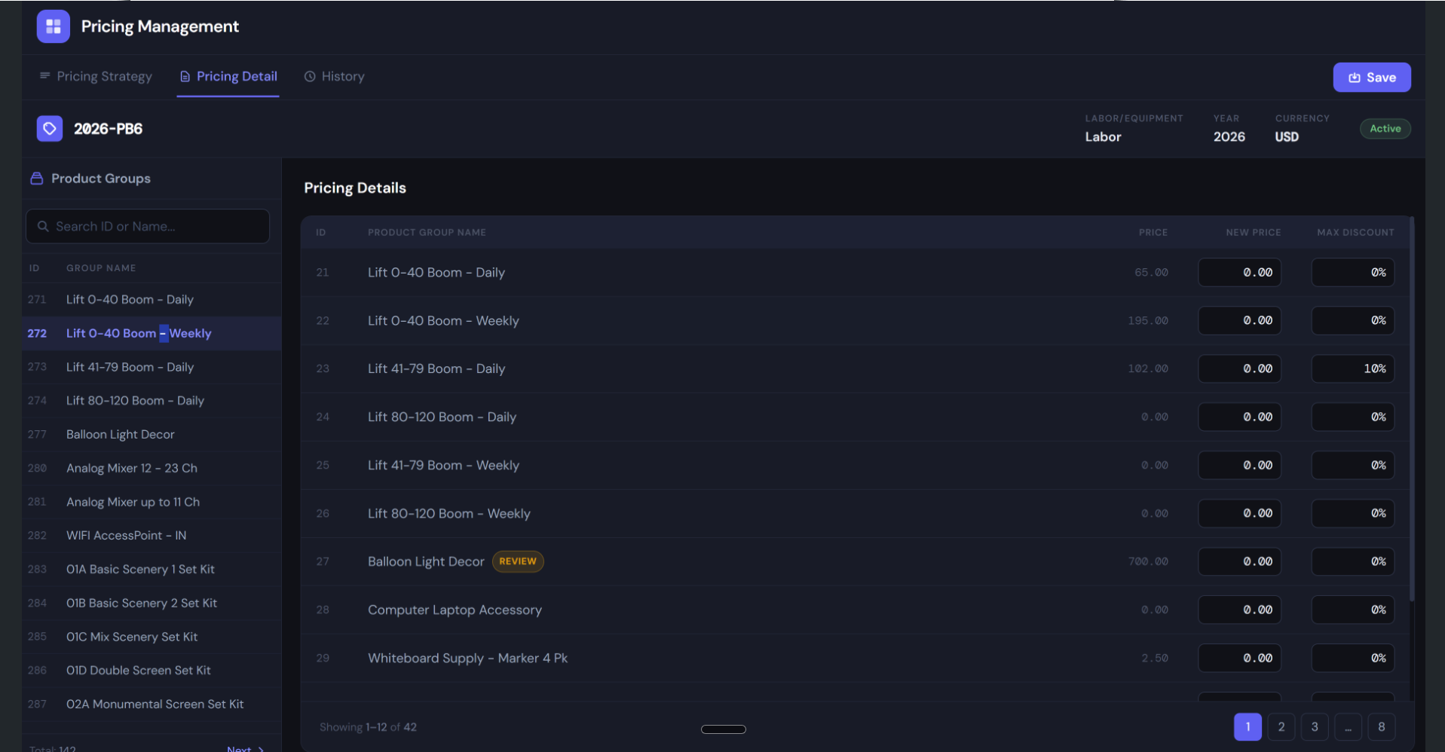

Product Details in New pricing